CALA 5

CANDIDATE NAME: Nyoni Vuyo

CANDIDATE #NO: 3041

LEARNING AREA: Computer Science

LEVEL: O’Level

CALA TYPE: Practical activity plus computer

TOPIC: Web Designing

**BACKGROUND**

Luveve High School is an educational institution which offers secondary and high school. It is located in Bulawayo. The institution offers quality education to students. The school has 1879 students and 81 teachers. It was established in 1959 as a Technical School for the Blacks during the Colonial Regime as a response to the then Rhodesian Prime Minister Sir Garfield Todd.

**PROBLEM**

Problem faced by Luveve High, it lacks an online presence, making it difficult to showcase activities, achievements, and facilities, and miss out on attracting potential students, parents, and teachers. Secondly, the absence of a website leads to a decentralized communication system, making it hard to disseminate announcements and updates effectively. This inconvenience extends to parents and students who struggle to access crucial information like calendars and policies. Additionally, the school may miss recruitment opportunities as prospective parents and students find it challenging to gather information. Moreover, the absence of a website hampers the school's ability to showcase student achievements and events, limiting recognition and opportunities. Lastly, accessibility suffers as individuals with disabilities are excluded from accessing essential information. These issues collectively impact the school's online presence, communication, marketing, information dissemination, and engagement with stakeholders

DOCUMENTATION

User documentation

HOME PAGE

<!DOCTYPE html>

<html lang="en">

<head>

<meta charset="UTF-8">

<title>LUVEVE HIGH SCHOOL</title>

</head>

<body>

<h1><u>WELCOME TO LUVEVE HIGH</u></h1>

<br>

<img src="ak.jpg" style="width: 50px; height: 50px;" />

<h2><u>INTRODUCTION</u></h2>

<p>Luveve High School is a reputable educational institution located in the heart of Luveve, Zimbabwe. With its long-standing history and commitment to academic excellence, it has established itself as one of the leading schools in the region.

</p>

<img src="a.jpg" style="width: 450px; height:250px;" ><br>

<ul>

<li>This is a map of Luveve high showing you directions</li>

</ul>

<a href="luvevehigh2.html">DETAILS</a>

</body>

</html>

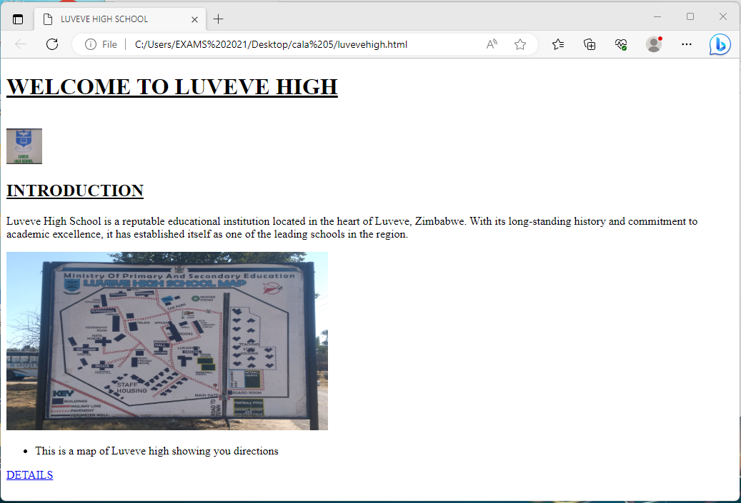

DESCRIPTION PAGE

<!DOCTYPE html>

lang="en">

<head>

<meta charset="UTF-8">

<title>LHS</title>

</head>

<body>

<h1> <b><u>LUVEVE HIGH SCHOOL</u></b></h1>

<p>The school boasts a well-rounded curriculum that emphasizes both academic achievement and personal development. Students at Luveve High School have access to a wide range of subjects, including mathematics, science, humanities, languages, and the arts. The dedicated and highly qualified teaching staff ensures that students receive a quality education and are well-prepared for their future endeavors.</p><br>

<img src="k.jpg" style="width: 450px; height:250px;" > <br>

<p>luveve administration place</p>

<p>In addition to its strong academic program, Luveve High School offers a variety of extracurricular activities to enhance students overall learning experience. These activities include sports teams, clubs, and societies, allowing students to pursue their interests and develop valuable skills outside the classroom. The school also organizes regular educational trips and competitions to broaden students' horizons and foster a spirit of healthy competition.

</p><br>

<img src="c.jpg" style="width: 450px; height:250px;" >

<p>Luveve High School prides itself on its state-of-the-art

facilities, providing students with a conducive learning environment. The classrooms are equipped with modern technology to facilitate interactive and engaging learning experiences. The school also has well-maintained laboratories, a well-stocked library, and sports facilities that cater to various interests and talents.</p><br><img src="g.jpg" style="width: 450px; height:250px;" >

<p>Furthermore, the school places a strong emphasis on discipline and character development. Through various programs and initiatives, students are encouraged to cultivate values such as respect, responsibility, and integrity. Luveve High School also promotes a culture of inclusivity and diversity, ensuring that every student feels valued and supported.

</p><br>

<img src="i.jpg" style="width: 450px; height:250px;" >

<p>With a track record of producing high-achieving students, Luveve High School has gained recognition both locally and internationally. Its graduates have gone on to excel in various fields, including academia, business, and the arts. The school's commitment to nurturing well-rounded individuals has undoubtedly contributed to their success.</p>

<a href="aboutus.html">VIEW MORE ABOUT US </a>

<br>

<a href="luvevehigh.html">BACK TO HOME PAGE </a>

</body>

</html>

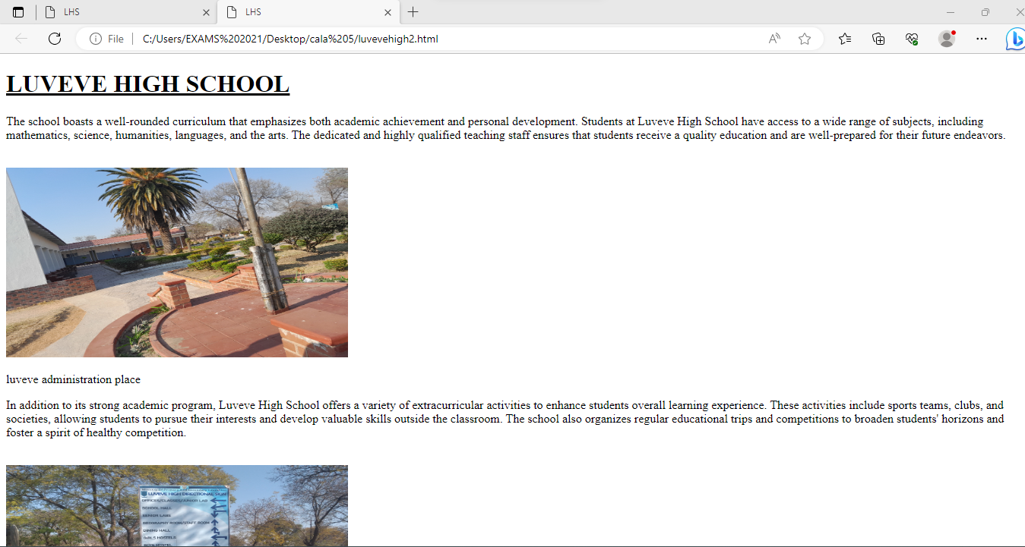

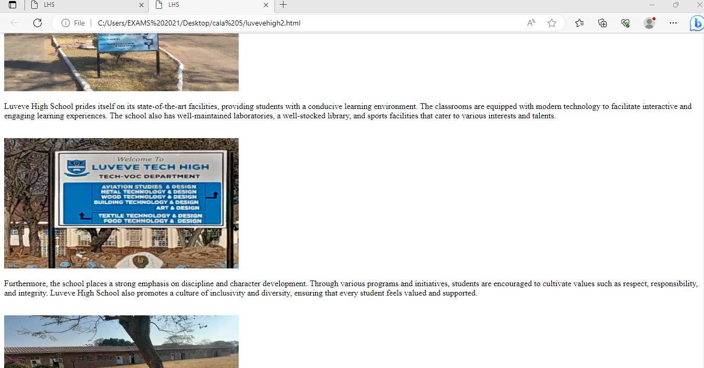

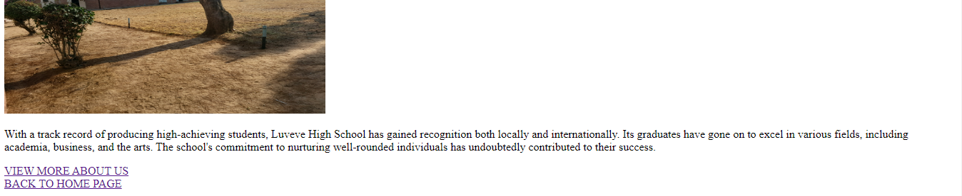

ABOUT PAGE

!DOCTYPE html>

<html lang="en">

<head>

<meta charset="UTF-8">

<title>LUVEVE HIGH</title>

</head>

<body>

<h2><u>About us</u></h2>

<p>Overall, Luveve High School is a prestigious institution that prioritizes academic excellence, personal development, and holistic education. Its dedication to providing a nurturing and inclusive learning environment makes it an ideal choice for students seeking a quality education.</p>

<img src="b.jpg" style="width: 450px; height:250px;" ><br>

<li>Luveve symbol</li>

<img src="e.jpg" style="width: 450px; height:250px;" >

<li>Luveve bus also known as nomvemve</li>

<h2>STUDENT RESULT</h2>

<table>

<thead>

<tr>

<th> Name </th>

<th> Subject </th>

<th> Symbol </th>

</tr>

</thead>

<tbody>

<tr>

<td> John </td>

<td> Maths</td>

<td> B</td>

</tr>

<tr>

<td> " </td>

<td> Engilsh</td>

<td> A </td>

</tr>

<tr>

<td> " </td>

<td> Ndebele</td>

<td> A </td>

</tr>

<tr>

<td> " </td>

<td> Geography</td>

<td> A </td>

</tr>

<tr>

<td> " </td>

<td> Physic</td>

<td> C </td>

</tr><tr>

<td> " </td>

<td> Biology</td>

<td> A </td>

</tr><tr>

<td> " </td>

<td> Combined Science</td>

<td> B </td>

</tr>

</tbody>

</table>

<a href="luvevehigh.html">HOME PAGE </a>

</body>

</html>

